**Assertions**

Assertions are used to perform additional checks on samplers, and are processed after every sampler in the same scope. To ensure that an Assertion is applied only to a particular sampler, add it as a child of the sampler.

**Note:** Unless documented otherwise, Assertions are not applied to sub-samples (child samples) – only to the parent sample. In the case of BSF and BeanShell Assertions, the script can retrieve sub-samples using the method prev.getSubResults() which returns an array of Sample Results. The array will be empty if there are none.

Versions of Jmeter after 2.3.2 include the option to apply certain assertions to the main sample, the sub-samples or both. The default is to apply the assertion to the main sample only.

Assertion help verify that your server under test returns the**expected** results.

Following are some commonly used Assertion in JMeter:

* [Response Assertion](http://www.guru99.com/assertions-in-jmeter.html#ResponseAssertion)
* [Duration Assertion](http://www.guru99.com/assertions-in-jmeter.html#DurationAssertion)
* [Size Assertion](http://www.guru99.com/assertions-in-jmeter.html#SizeAssertion)
* [XML Assertion](http://www.guru99.com/assertions-in-jmeter.html#XMLAssertion)
* [HTML Assertion](http://www.guru99.com/assertions-in-jmeter.html#HTMLAssertion)

**Response Assertion:**The response assertion lets you add pattern strings to be compared against various fields of the server response.

For example, you send a user request to the website [http://www.google.com](http://www.google.com/) and get the server response. You can use Response Assertion to verify if the server response contains expected pattern string (e.g. "OK").

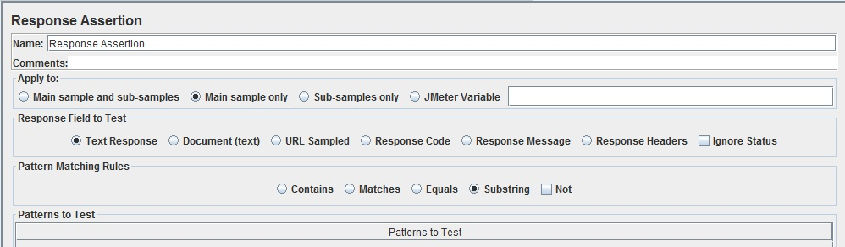

**Parameters:**

|  |  |  |  |  |  |  |  |  |  |  |  |  |  |  |  |  |
| --- | --- | --- | --- | --- | --- | --- | --- | --- | --- | --- | --- | --- | --- | --- | --- | --- |
| |  |  |  |  |  |  |  |  |  |  |  |  |  |  |  |  | | --- | --- | --- | --- | --- | --- | --- | --- | --- | --- | --- | --- | --- | --- | --- | --- | | |  |  |  |  |  |  |  |  |  |  |  |  |  |  |  | | --- | --- | --- | --- | --- | --- | --- | --- | --- | --- | --- | --- | --- | --- | --- | | |  |  | | --- | --- | | **Attribute** | **Description** | | Name | Descriptive name for this element that is shown in the tree. | | Apply to: | This is for use with samplers that can generate sub-samples, e.g. HTTP Sampler with embedded resources, Mail Reader or samples generated by the Transaction Controller.   * Main sample only - assertion only applies to the main sample * Sub-samples only - assertion only applies to the sub-samples * Main sample and sub-samples - assertion applies to both. * JMeter Variable - assertion is to be applied to the contents of the named variable | | Response Field to Test | Instructs JMeter which field of the Response to test.   * Text Response - the response text from the server, i.e. the body, excluding any HTTP headers. * Document (text) - the extract text from various type of documents via Apache Tika (see View Results Tree Document view section). * URL sampled * Response Code - e.g. 200 * Response Message - e.g. OK * Response Headers, including Set-Cookie headers (if any) | | Ignore status | Instructs JMeter to set the status to success initially.  The overall success of the sample is determined by combining the result of the assertion with the existing Response status. When the Ignore Status checkbox is selected, the Response status is forced to successful before evaluating the Assertion.  HTTP Responses with statuses in the 4xx and 5xx ranges are normally regarded as unsuccessful. The "Ignore status" checkbox can be used to set the status successful before performing further checks. Note that this will have the effect of clearing any previous assertion failures, so make sure that this is only set on the first assertion. | | Pattern Matching Rules | Indicates how the text being tested is checked against the pattern.   * Contains - true if the text contains the regular expression pattern * Matches - true if the whole text matches the regular expression pattern * Equals - true if the whole text equals the pattern string (case-sensitive) * Substring - true if the text contains the pattern string (case-sensitive)   Equals and Substring patterns are plain strings, not regular expressions. NOT may also be selected to invert the result of the check. | | Patterns to Test | A list of patterns to be tested. Each pattern is tested separately. If a pattern fails, then further patterns are not checked. There is no difference between setting up one Assertion with multiple patterns and setting up multiple Assertions with one pattern each (assuming the other options are the same). **However, when the Ignore Status checkbox is selected, this has the effect of cancelling any previous assertion failures - so make sure that the Ignore Status checkbox is only used on the first Assertion.** | | | |

[**Duration Assertion**](http://www.guru99.com/assertions-in-jmeter.html#DurationAssertion)**:** The Duration Assertion tests that each response was received within a give amount of time. Any response that takes longer than the give number of milliseconds (specified by the user) is marked as a failed response.

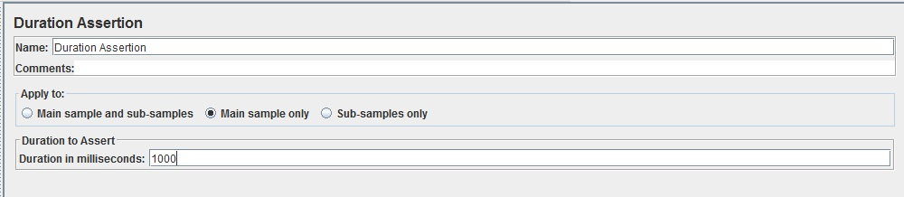

**Parameters:**

|  |  |  |  |  |  |  |  |  |
| --- | --- | --- | --- | --- | --- | --- | --- | --- |
| |  |  |  |  |  |  |  |  | | --- | --- | --- | --- | --- | --- | --- | --- | | |  |  |  |  |  |  |  | | --- | --- | --- | --- | --- | --- | --- | | |  |  | | --- | --- | | **Attribute** | **Description** | | Name | Descriptive name for this element that is shown in the tree. | | Duration in Milliseconds | The maximum number of milliseconds each response is allowed before being marked as failed. | | | |

[**Size Assertion**](http://www.guru99.com/assertions-in-jmeter.html#SizeAssertion)**:** The Size Assertion tests that each response contains the right number of bytes in it. You can specify that the size be equal to, greater than, less than, or not equal to a give number of bytes.

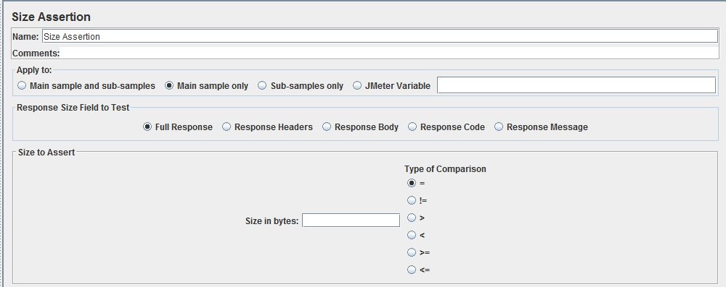

**Parameters:**

|  |  |  |  |  |  |  |  |  |  |  |  |  |
| --- | --- | --- | --- | --- | --- | --- | --- | --- | --- | --- | --- | --- |
| |  |  |  |  |  |  |  |  |  |  |  |  | | --- | --- | --- | --- | --- | --- | --- | --- | --- | --- | --- | --- | | |  |  |  |  |  |  |  |  |  |  |  | | --- | --- | --- | --- | --- | --- | --- | --- | --- | --- | --- | | |  |  | | --- | --- | | **Attribute** | **Description** | | Name | Descriptive name for this element that is shown in the tree. | | Apply to: | This is for use with samplers that can generate sub-samples, e.g. HTTP Sampler with embedded resources, Mail Reader or samples generated by the Transaction Controller.   * Main sample only - assertion only applies to the main sample * Sub-samples only - assertion only applies to the sub-samples * Main sample and sub-samples - assertion applies to both. * JMeter Variable - assertion is to be applied to the contents of the named variable | | Size in bytes | The number of bytes to use in testing the size of the response (or value of the JMeter variable). | | Type of Comparison | Whether to test that the response is equal to, greater than, less than, or not equal to, the number of bytes specified. | | | |

[**XML Assertion**](http://www.guru99.com/assertions-in-jmeter.html#XMLAssertion)**:**The XML Assertion tests that the response data consists of a formally correct XML document. It does not validate the XML based on a DTD or schema or do any further validation.

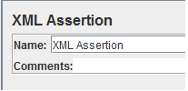

**Parameter:**

|  |  |  |  |  |  |  |
| --- | --- | --- | --- | --- | --- | --- |
| |  |  |  |  |  |  | | --- | --- | --- | --- | --- | --- | | |  |  |  |  |  | | --- | --- | --- | --- | --- | | |  |  | | --- | --- | | **Attribute** | **Description** | | Name | Descriptive name for this element that is shown in the tree. | | | |

**HTML Assertions:** The HTML Assertion allows the user to check the HTML syntax of the response data using JTidy.

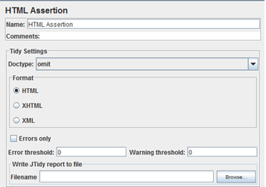

**Parameters:**

|  |  |  |  |  |  |  |  |  |  |  |  |  |  |  |  |  |  |  |  |  |  |  |  |  |  |  |
| --- | --- | --- | --- | --- | --- | --- | --- | --- | --- | --- | --- | --- | --- | --- | --- | --- | --- | --- | --- | --- | --- | --- | --- | --- | --- | --- |
| |  |  |  |  |  |  |  |  |  |  |  |  |  |  |  |  |  |  |  |  |  |  |  |  |  |  | | --- | --- | --- | --- | --- | --- | --- | --- | --- | --- | --- | --- | --- | --- | --- | --- | --- | --- | --- | --- | --- | --- | --- | --- | --- | --- | | |  |  |  |  |  |  |  |  |  |  |  |  |  |  |  |  |  |  |  |  |  |  |  |  |  | | --- | --- | --- | --- | --- | --- | --- | --- | --- | --- | --- | --- | --- | --- | --- | --- | --- | --- | --- | --- | --- | --- | --- | --- | --- | | |  |  |  | | --- | --- | --- | | **Attribute** | **Description** | **Required** | | Name | Descriptive name for this element that is shown in the tree. | No | | doctype | omit/auto/strict/loose | Yes | | Format | HTML, XHTML or XML | Yes | | Errors only | Only take note of errors? | Yes | | Error threshold | Number of errors allowed before classing the response as failed | Yes | | Warning threshold | Number of warnings allowed before classing the response as failed | Yes | | Filename | Name of file to which report is written | No | | | |